PAUWELS TRAVEL BUREAU LTD

Mailing Address: 43 Condor Street, Kitchener, Ontario, N2K 0B2, Canada

519-753-2695 | tours@pauwelstravel.com

www.pauwelstravel.com | Ont. Reg. #1034992

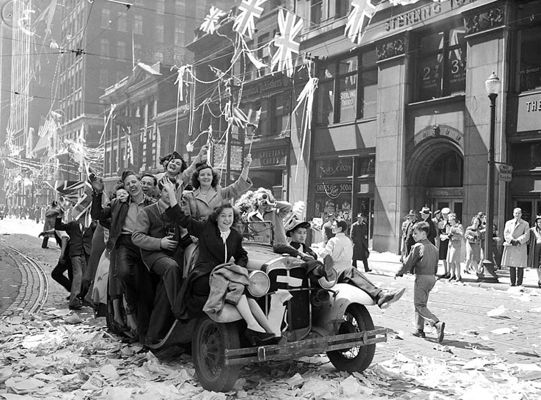

VE-Day Celebrations in Toronto on May 8, 1945

1945 VICTORY ANNIVERSARY TOUR

15 days: Thursday, May 1 to Thursday, May 15, 2025

A tour of: Normandy Landing Beaches – Dieppe – Vimy and Baumont-Hamel Canadian Memorials – Flanders Fields with Ypres and Passchendaele – Scheldt Battlefield - ‘Bridge too Far’ area in Holland –Battle of the Bulge sites in the Ardennes Forest – Luxembourg and the Maginot Line –1918 and 1945 Armistice sites in Reims and Compiègne – plus an optional extension to Berlin.An extensive exploration of the battlefields of Northern France, Belgium, and the Netherlands, focusing on the Canadian contribution to victory in both world wars. Accommodation in a combination of first-class/four-star and superior tourist-class/three-star hotels, breakfast daily and seven dinners, plus history lectures by your tour escort, historian Jacques R. Pauwels, author of ‘The Myth of the Good War’, ‘The Great Class War 1914-1918’, ‘The Canadians and the Liberation of Belgium 1944’, and other books on both world wars.

Tour Price: $5,495 CAD*

*From Toronto, based on double occupancy

Land Only: $4,345 CAD

Single room supplement: $ 1,225 CAD

PROPOSED ITINERARY

Day 1 - Thursday, May 1: Evening departure from Toronto to Paris with Air Canada. Dinner and a light breakfast will be served on board.

Day 2 – Friday, May 2: Morning arrival at Paris CDG Airport. Transfer by private coach to the historic city of Caen in Normandy, the hub of the province’s area that witnessed the Allied landings on D-Day and the subsequent “Battle of Normandy” of the summer of 1944. Accommodation in the [Hotel Holiday Express](https://www.ihg.com/holidayinnexpress/hotels/us/en/epron/cfrep/hoteldetail) on the outskirts of the city, and dinner in a nearby restaurant.

Days 3 and 4 – Saturday, May 3, and Sunday, May 4: First of two full days of sightseeing in Normandy. Among the highlights will be Juno Beach (the Canadian sector of the Landing Beaches) with the excellent Juno Beach Centre in Courseulles-sur-Mer; the Canadian War Cemetery of Bény-sur-Mer; Arromanches with the remains of the great artificial ‘Mulberry’ harbour; Ardenne Abbey, where Canadian POWs were executed by SS troops; the picturesque town of Bayeux, with its famous "Tapestry,” a medieval embroidered “comic strip” showing the conquest of England by William, Duke of Normandy. Also free time to explore Caen, the city of William the Conqueror, which suffered much damage during the fighting but was carefully rebuilt after the war.

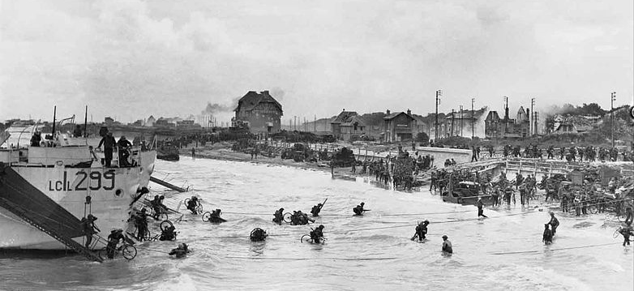

*<Canadian troops disembarking at Bernières, Juno Beach*

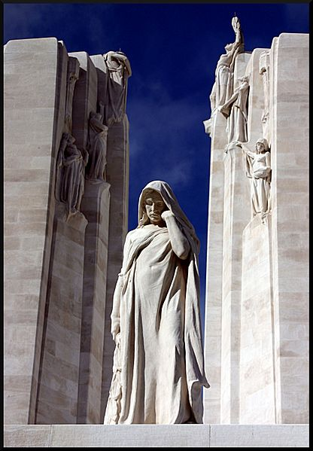

< *Detail of the Vimy Memorial*

Day 5 – Monday, May 5: After breakfast, departure for Dieppe, the Normandy seaport where Canadian troops came ashore in a 1942 raid that caused heavy losses but was justified as a general rehearsal for the 1944 Normandy landings. On to the Somme Battlefield of World War I, scene of General Haig’s “Big Push”, a great British offensive launched on July 1, 1916. Visits to the massive British Memorial of Thiepval as well as the Newfoundland Caribou Monument and small museum at Beaumont-Hamel. Dinner and overnight in the [Holiday Inn Express](https://www.ihg.com/holidayinnexpress/hotels/us/en/arras/lilar/hoteldetail) in the picturesque town of Arras.

Day 6 – Tuesday, May 6: Morning visit to nearby Vimy for a comprehensive tour of the stunning Canadian Memorial and Battlefield Park. Afterwards we explore other nearby monuments and cemeteries associated with the heavy fighting in this area, including the French and British cemeteries at La Targette, the hill of Notre Dame de Lorette, and Neuville-St Vaast German war cemetery. Return to Arras in late afternoon and rest of the day at leisure to explore the picturesque old town on your own.

Day 7 – Wednesday, May 7: Departing from Arras after breakfast, we soon cross into Belgium and tour [Flanders Fields](https://www.visitflanders.com/en/discover-flanders/arts-and-heritage/flanders-fields/27-wwi-memorial-sites-flanders-fields), the quintessential ‘killing fields’ of WW I, stretching from the French border to the North Sea, recently designated as a UNESCO World Heritage Site. The major sights here are the town of Ieper (aka Ypres) with its Menin Gate Memorial, the impressive British war memorial; Essex Farm Cemetery, where John McRae composed his famous poem; the Canadian monument known as “the Brooding Soldier”; the village of Passchendaele, in whose muddy fields Canadian troops fought an epic battle in 1917; and Tyne Cot Cemetery, the largest Commonwealth War Cemetery in the world. Late afternoon arrival in beautiful Bruges, one of the best-preserved medieval cities in Europe. The town was liberated by a Canadian Army unit from Manitoba, and we enter the city, as they did, via a bridge now known as the Manitoba Dragoons Bridge. Dinner and overnight in the centrally-located first-class [Hotel LeBoisDeBruges](https://leboisdebruges.be/en).

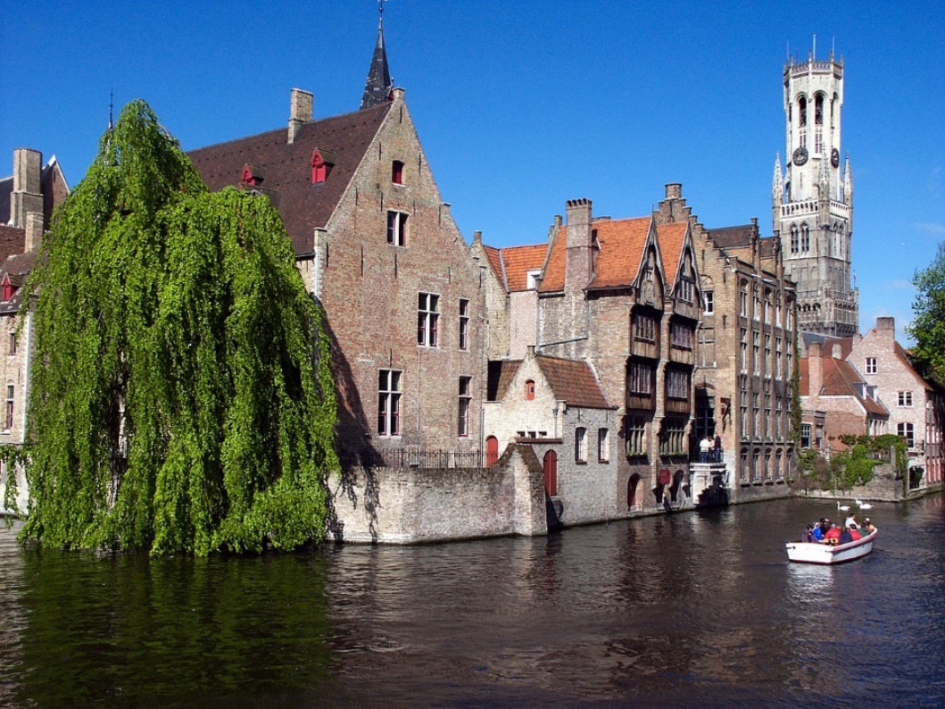 *Picturesque Old Bruges >*

Day 8 – Thursday, May 8: This morning, leisurely walking tour of Bruges. Highlights include the Belfry, symbol of the city; the Church of Our Lady; the Gothic Town Hall; medieval St. John’s Hospital; the Lake of Love; the romantic Beguinage; and a boat tour on the scenic canals that crisscross the town! Remainder of the day at leisure. This evening, *optional* dinner of Flemish culinary specialties and performance by musicians specializing in medieval music!

Day 9 - Friday, May 9: Departure from Bruges after breakfast. We explore the area along the Belgian-Dutch border where the Canadian Army fought the crucial “Battle of the Scheldt” in the Fall of 1944, visiting sites such as the Moerbrugge and Moerkerke battlefields along the Leopold Canal and the Canadian War Cemetery in the village of Adegem. On to the great seaport of Antwerp, which became available for use by the Allies as a result of the Canadian victory in the Battle of the Scheldt, and into Holland for dinner and overnight in the first-class [Fletcher Parkhotel Val Monte](https://www.parkhotelvalmonte.nl/en) near Nijmegen, a town situated near the German border. The Canadian army spent the winter of 1944 in this area, fighting numerous battles in the area, and started the spring 1945 offensive that led to the liberation of Holland.

Day 10 - Saturday, May 10: Today we first visit the town of Arnhem, situated on the banks of the mighty Rhine River, associated with Operation Market Garden of September 1944, featured in the famous movie “A Bridge Too Far”. On to the town of Wageningen for a visit to Hotel De Wereld, in which the German army occupying Holland capitulated to the Canadians on May 5, 1945. During a gourmet lunch in this historic hotel, in the room where the German capitulation took place, you will hear all about this proud moment in Canada’s military history! Returning to the Nijmegen area in the afternoon, we visit Groesbeek Canadian War Cemetery and the adjoining museum. Evening at leisure.

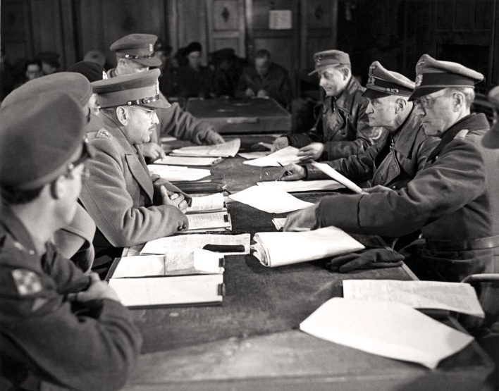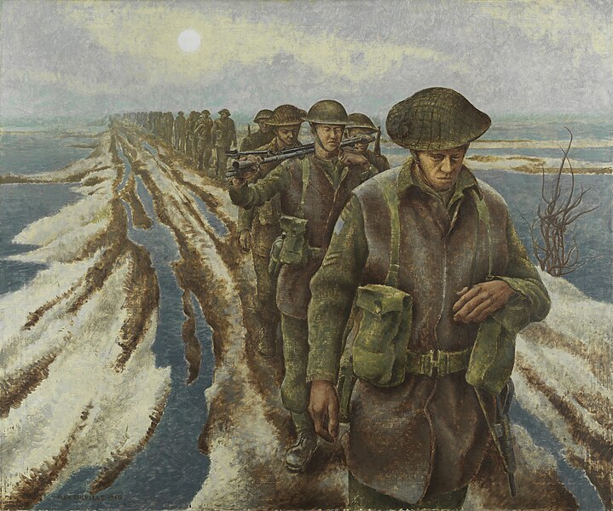

*Canadian infantry near Nijmegen on a painting by Alex Colville – The German surrender in Wageningen*

Day 11 - Sunday, May 11: Departure after breakfast. We cross into Germany and briefly explore the Reichswald Forest, an area that witnessed heavy fighting in the spring of 1945 as the Allies moved to cross the Rhine and Canadian troops swung back into Holland to complete the country’s liberation. Then we motor southward, cross back into Belgium near the city of Liège, and enter the vast, beautiful, and now peaceful Ardennes Forest, scene of the famous Battle of the Bulge of the winter of 1944-45. Visit to the American Mardasson Memorial and Museum at Bastogne, and late afternoon arrival at our hotel in Luxembourg, quaint capital of the homonymous Grand Duchy. Dinner and overnight in the superior three-star [Hotel Park Plaza](https://www.goereshotels.com/en/parc-plaza-en).

Day 12 - Monday, May 12: Morning sightseeing in Luxembourg, with the very picturesque fortified old town and the American War Cemetery, featuring the tomb of General Patton. Crossing the nearby border into France, we visit the Hackenberg fortress of the famous Maginot Line, a memorable experience! In the afternoon we motor via Metz to Verdun for a short visit to that town, the focal point of a murderous battle in 1916, then continue to the city of Reims in the Champagne Country for dinner and overnight.

Day 13 - Tuesday, May 13: Our local sightseeing program in Reims will include visits to the "War Room", the former school where, on May 7, 1945, General Eisenhower accepted a German surrender that went into effect the following day, when a second capitulation took place in Marshal Zhukov’s HQ in Berlin. Also visits to the city’s famous Gothic Cathedral, rebuilt after its destruction in WW I, and to a Champagne firm (including a tasting, of course), to celebrate the 80th anniversary of the end of WW II! No group dinner this evening, but it will be possible to enjoy an optional gourmet dinner in one of the city’s many fine restaurants.

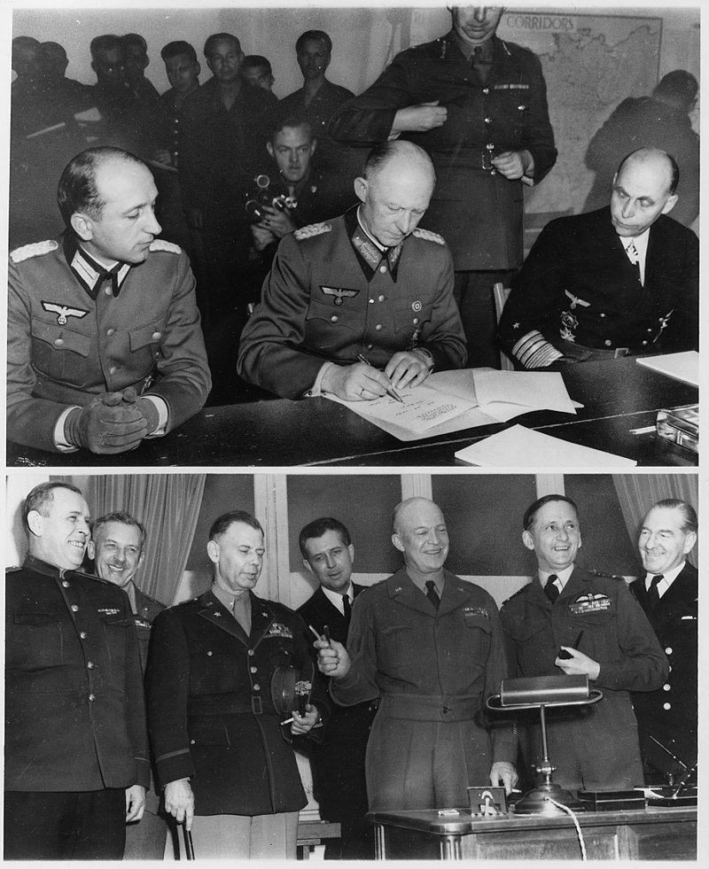

< *General Jodl signs the German capitulation in Reims*

Day 14 - Wednesday, May 14: Departure from Reims after breakfast. We motor across WW I battlefields toRethondes, a hamlet in the Forest of Compiègne, where the Germans surrendered on November 11, 1918 in the railway carriage that served as the HQ of Allied Commander in Chief, Marshal Foch; it is also here that the French capitulated on June 22, 1940. On to Mons in Belgium, a city liberated by Canadian troops on November 11, 1918, only hours after the signing of the armistice in Rethondes, and visit to the grave of the last Canadian soldier killed in the Great War, merely minutes before the guns fell silent at 11 AM! Overnight in the 4-star [B&B Hotel Mons Center](https://www.hotel-bb.com/en/hotel/mons-centre?gad_source=1&gclsrc=ds) and “au revoir”-dinner in a typical restaurant.

Day 15 – Thursday, May 15: After breakfast, transfer to Brussels Airport in time for the departure of our Air Canada return flight to Toronto, via Montreal.

Tour price, based on double occupancy, from Toronto: $5,495 CAD

Land Only, from Paris CDG Airport: $4,345 CAD

Single room supplement: $1,225 CAD

AN OPTIONAL 5-DAY EXTENSION TO **BERLIN** MAY BE OFFERED,

PLEASE ADVISE ASAP IF YOU ARE INTERESTED!

Included in the tour price are:

* Economy class return flight from Toronto to Paris, returning from Brussels with Air Canada.
* Accommodation in a combination of 3-star/superior tourist-class and 4-star/first-class hotels, based on double occupancy.
* Meals: buffet breakfast daily and a total of *seven* full dinners or lunches.
* Overland transportation via private coach.
* Sightseeing, visits, and excursions as indicated in the itinerary.

Not included are:

* All expenses of a personal nature.
* Meals other than those mentioned above.
* Beverages with dinners.
* Coach drivers’ gratuity of 30 Euros, to be paid locally.
* Travel insurance is available upon request.

YOUR TOUR HOST AND GUIDE: JACQUES R. PAUWELS

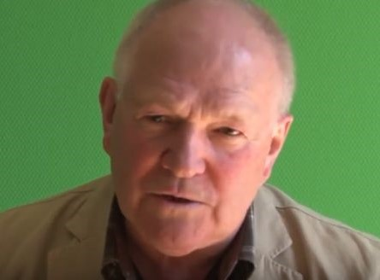

Historian Jacques R. Pauwels is an expert in the history of both world wars. He is the author of *The Great Class War 1914-1918, Big Business and Hitler,* and *The Myth of the Good War: America in the Second World War*, books translated in as many as nine languages, including French, German, Italian, and Spanish. Another book on WW II, *The Canadians and the Liberation of Belgium,* is unfortunately available only in Dutch. Jacques has been planning and conducting tours of the battlefields of WW I and II in France, Belgium, the Netherlands, Luxembourg, and Germany, since the 1990s.

**REGISTRATION FORM**

Please book _________ seat(s) on the Victory Anniversary Tour from May 1 – 15, 2025.

I wish to book flights_____ OR land only ______.

(If booking land only please send the office a copy of your flight details).

Please be prepared to pay a deposit of **$1000 per person and any applicable insurance premium** at time of registration. Balance is invoiced no later than 60 days prior to departure.

WE REQUIRE A COPY OF YOUR PASSPORT (INFORMATION PAGES ONLY) VALID 6 MONTHS AFTER THE TOUR TO BE SENT IN WITH YOUR REGISTRATION FORM.

PASSPORT NAME(S):

Surname First Middle(s)

Date of Birth (ddmmmyyyy):

Surname First Middle(s)

Date of Birth (ddmmmyyyy):

Address: City:

Postal Code: Phone: Cell Phone:

Email:

If traveling alone, is a **single room** required? Yes No

If sharing, what is your bed preference: twin (2 beds) double (1 bed) ?

SPECIAL REQUIREMENTS: Please list any dietary requests, allergies, special physical needs, or frequent flyer numbers etc., below. We cannot ensure requests made 30 days or less prior to departure will be possible.

INSURANCE: Review plans and rates by clicking [here](https://www.igoinsured.com/Direct/ManulifeGlobal.aspx?ag=pauwbrt&lang=E) or calling the office. Record your quoted premium below:

All-Inclusive: Emergency Medical: Non-Medical/Trip Cancellation:

Decline Insurance:

PAYMENT: Cheque payable to Pauwels Travel Bureau LTD, e-transfer to [tours@pauwelstravel.com](mailto:tours@pauwelstravel.com) or call the office to provide credit card (Visa, Mastercard, American Express) to Sandra or Jessica.

Amount To Pay: ______________

CONSENT: “I/we have read and agree to the terms and conditions attached to the tour program, have selected or declined insurance, indicated any special requests, and authorize payment of the deposit and/or any quoted insurance.”

Date_______ Signature____________________________

Date_______ Signature____________________________

PAUWELS TRAVEL BUREAU LTD.

Mailing Address: 43 Condor St, Kitchener, ON, N2K 0B2

Tel: 519-753-2695/1-800-380-3974 – Fax: 519753-6376 - Email: [tours@pauwelstravel.com](mailto:tours@pauwelstravel.com)

**TERMS & CONDITIONS**

RESERVATIONS AND DEPOSITS:

Reservations should be made as early as possible to ensure the departure of your choice. No reservations will be accepted without a deposit and signed registration form. Deposit amounts vary by tour and are listed in the registration form.

REFUND OF UNUSED ARRANGEMENTS:

Because the rates of Pauwels Travel Bureau Ltd. are based on group participation, no refund can be made for any tour accommodation or tour service, or tour feature not taken. If cancellation occurs while the tour is in progress, no refund can be made for the tour portion not taken. We strongly suggest that to allow for any unexpected contingencies, you purchase the all-inclusive insurance.

CANCELLATION POLICY:

Refund of deposit is made if cancellation is received in writing by Pauwels Travel Bureau Ltd. at least 91 days prior of the departure date of the tour less a $250.00 non-refundable administrative fee per person. For cancellation received in writing 90 days prior or less the following cancellation penalties apply for tour costs:

* 90 days to 61 days before departure: 35% of tour cost
* 60 to 31 days before departure: 65% of tour cost
* 30 – 0 days prior to departure: 100% of tour cost

Penalties for cancelling insurance or individual airfare may differ than the policy above. Clients are advised to review the cancellation terms for any additional services they may have purchased for the tour.

RESPONSIBILITY:

The acceptance of the initial service to be provided under the tour shall be considered an acceptance by the tour member of those conditions. We also reserve the right to decline, to accept or retain any person as a member of the tour. We reserve the right without notice, to withdraw any part or all of the tour. Factors such as airline schedule changes, hotel overbookings, inclement weather, travel warnings by the Canadian Government etc. may necessitate changes in the itinerary. There may also be other circumstances in which changes become necessary or advisable. By commencing the tour, I agree to the release and agreement as included below.

RELEASE & AGREEMENT:

By placing my deposit, submitting my registration, and commencing the tour I understand and agree to the following:

1. That all tours are delivered in conjunction with other service providers, including but not limited to travel agent and booking services, airlines, hotel and accommodation providers, transportation providers including but not limited to coach, train and ferry services, restaurant providers, and local guides. We shall not be held responsible for the failure by any person or company to render any transportation, lodging or other travel service to be provided on the tour. All hotels, transportation and other travel services are provided subject to all the terms and conditions under which they are offered to the public generally.

2. I know that tour programs include walking and may including hiking and fitness programs that have potentially hazardous activities associated with them. I should not participate prior to approval by my physician. I assume any and all other risks associated with these events included but not limited to falls, contact with other participants, the effects of the weather including high heat and/or humidity.

3. To release, indemnify and hold harmless Pauwels Travel Bureau and their affiliates (which term shall include parents, subsidiaries, officers, directors, shareholders, agents and employees of Pauwels Travel Bureau as well as Pauwels Travel themselves) (the “Released Parties”) from, and agree not to sue the Released Parties for, any claims that I may have arising from, or in connection with, any personal injury, bodily injury, mental anguish, emotional distress, physical, property or other damage that I may suffer from any cause whatsoever related in any way to my participation in this tour. Without limiting the generality of the foregoing, I release, indemnify, and hold harmless the Released Parties from, and agree not to sue them for any personal injury, bodily injury, mental anguish, emotional distress, physical, property or other damage that I may suffer from the Released Parties’ negligence other than from intentional or reckless acts by such parties. I further agree to release, indemnify and hold harmless the Released Parties from any and all acts of God, war (whether declared or undeclared), terrorist activities, incidents of politically motivated violence, illness or quarantine, strikes or government restrictions or the acts or omissions of any other agents over which the Released Parties have no direct or indirect control, including, without limitation, airlines, railways, bus companies, hotels, shipping companies, guides and sub- contracted agents or tour operators. This release also includes activities not offered that may be considered risky. I further release any Tour Directors, bus drivers or other individuals involved in my tour.

4. That the air carrier’s liability for loss of or damage to baggage or property, or for death or injury to person, is limited by their tariffs, or the Warsaw Convention, or both.

5. That Pauwels Travel Bureau shall have no liability or responsibility for me when I am absent from activities, such as visits to friends or relatives or during pre-tour/post-tour option periods if the pre-tour/post-tour period does not include the services of a Tour Director.

6. To abide by directions of my Tour Director or other leadership personnel during my tour. Failure to do so may result in my termination from tour immediately. I understand that to disobey such rules or directions are to waive the right to any refund, and that I may be sent home at my own expense. The participant and family undertake full financial responsibility for any damage caused by the participant and agree to pay his/her return home on the first available flight, should his/her behaviour be deemed detrimental to the welfare of the group.

7. To abide by all local laws when in Canada and abroad, including those concerning drugs and alcohol. (Minors must have parents’ permission to use alcohol even if the local law would otherwise permit them to.) I understand that if I abuse or disobey such laws, even unintentionally, I waive my right to a refund, and Pauwels Travel may send me home at my own expense. I also understand that, should local authorities be involved, I will be subject to the laws of the country I am visiting.

8. That if I become ill or incapacitated, Pauwels Travel and its employees, or a designated chaperone may take any action they deem necessary for my safety and well-being, including securing medical treatment (at my own expense) and transporting me home. In the event of a medical emergency, Pauwels Travel will attempt to cause appropriate treatment to be administered, and the traveller authorizes Pauwels Travel to do so. Pauwels Travel, however, makes no warranty that it will be able to cause effective (or any) emergency treatment to be administered.

9. That Pauwels Travel may use any film likenesses taken of me and any of my comments while on a tour for future publication and use my contact information for future Pauwels Travel communications.

A WORD ABOUT GROUP AIRFARES:

Please note that when booking one of our air inclusive tours, Pauwels Travel has negotiated reduced rates with the airline that we are able to confirm and lock in up to 359 days before travel. While it is wonderful to share the savings and flexibility this provides with you, our valued guests, the privilege does come with some restrictions. In some cases, it may not be possible to collect frequent flyer miles, you may not be able to check in online 24 hours before travel, or you may need to try checking in with your ticket number rather than your booking reference. Additionally, most airlines do not allow advanced seat-selection on group airfares. It is the airline’s policy, not ours, that prevents us from assigning specific seats. If a request is made, it is passed on to the airline by our staff when they submit the names to the airline 60 days prior to departure but no requests are guaranteed. Our staff will not be able to aid in advanced seat selection if the airline does not allow it on the group airfare. If a certain type of seat is indispensable to you, we suggest that you book our tour on a “land only” basis and make individual flight arrangements, in which case you may be able to get the seat of your choice; Pauwels Travel would be happy to assist you with that reservation. We will offer you the best fare available, but please note that this can only be done once a tour is a guaranteed departure because individual airfare conditions are stricter than the conditions of the group airfare rate. We thank you in advance for your kind understanding of the above!